INTERVALS AND TRIADS
1. Name these intervals as 2nd, 3rd, 4th, etc (Count from the first note. Eg. the first one is a 5th G to D)
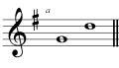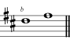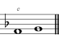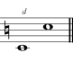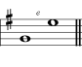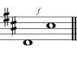
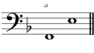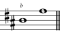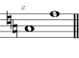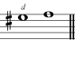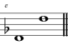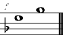
2. Above each note, write a higher note to make the interval.
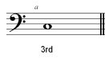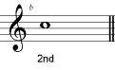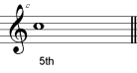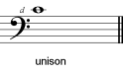
3. Name the keys of each of these tonic triads (e.g. C major).
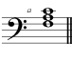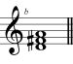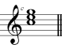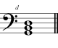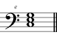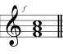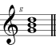

4. Add the correct clef and key signature to each of these tonic triads.
