NOTE RECOGNITION
1. Give the letter name of each of the notes marked *. The first answer is given.
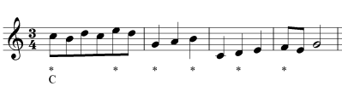
2. Write the notes which these letters represent. (Sometimes there are two possible positions)
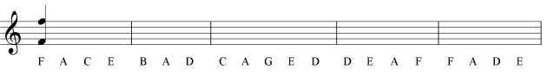
3. Give the letter name of each of the notes marked *.
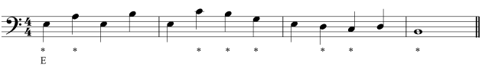
4. Write the notes which these letters represent. (Sometimes there are two possible positions, as in the first A.)
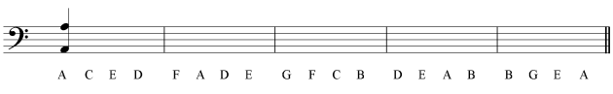
5. For each pair of notes, circle the one which is higher.
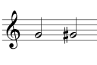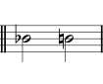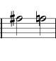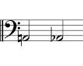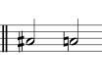
6. For each pair of notes, circle the one which is lower.
