NOTE VALUES
1. Give the time name of each note marked with a star (e.g. "minim" ). The first one has been done for you.
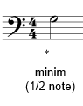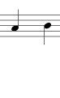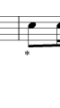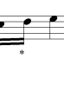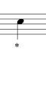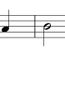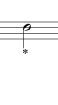
2. Put these notes in order of length, starting with the longest.
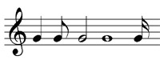
3. Give the note name and time name of each of the following notes.
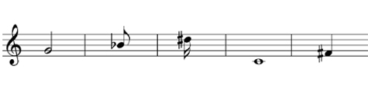
4. Give the note name and time name of each of the following notes.
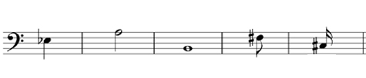
5. Next to each note, write a rest that has the same time value.
