RHYTHMS
Write an answering rhythm to each of these phrases.
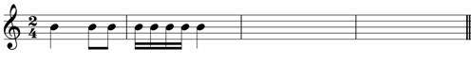

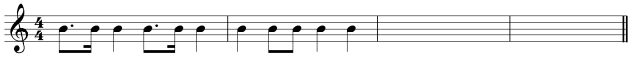
Now write your own rhythm.

