EXAMPLE QUESTION
1. Look at this melody, adapted from a piece by Schumann, and then answer the questions below.
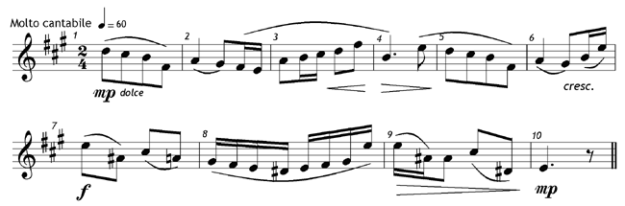 Give the meaning of each of these: (10 points)
Molto cantabile | =
=60 | =
dolce | =
cresc. | =
mp | =

Give the time name (e.g. crotchet or minim) of the rest in the last bar.
Draw a circle round two notes next to each other which are a 6th apart.
The key of the melody is A major. On which degree of the scale (e.g. 2nd, 3rd ) does the melody begin?
Answer TRUE or FALSE to this sentence: The time signature 2/4 means that there are two quaver beats in a bar.

