KEY SIGNATURES AND SCALES
1. Name the degree of the scale (e.g. 2nd, 3rd, 4th) of the notes marked *
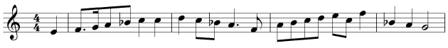
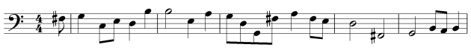
2. Name the major keys shown by these key signatures.

3. Add the correct key signatures to these bars.
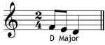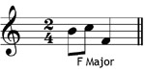
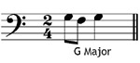
4. This melody uses all the notes of the scale of C major - true or false?
