NOTE RECOGNITION AND CHORDS
1. Give the letter name of each of the notes marked *, including the sharp or flat sign where necessary.
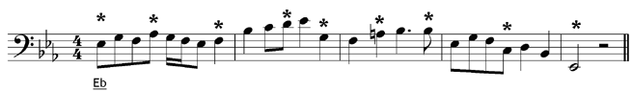
2. Add the correct clef and any necessary sharp or flat signs to each of these chords.

