WRITING MINOR SCALES
1. Add the missing notes to these minor scales.
E minor melodic 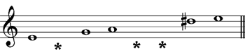
D minor harmonic 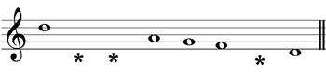
A minor harmonic 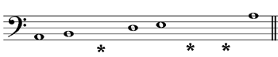
E minor melodic 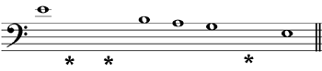
D minor melodic 