CHROMATIC SCALES
1. Write out one octave of the following chromatic scales in semibreves (whole notes):
Ascending, starting on F
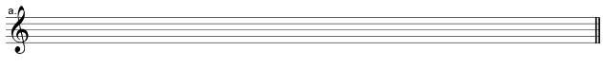
Ascending, starting on C
2. Write out one octave of the following chromatic scales in semibreves (whole notes):
Ascending, starting on F
Ascending, starting on B
3. Draw a circle around four notes next to each other that form part of a chromatic scale in the following pieces of music:
