NOTE RECOGNITION
1. Name each of these notes
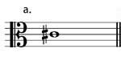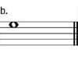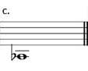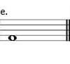
2. Write the notes stated as minims (half notes) and use ledger lines if necessary.
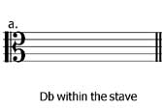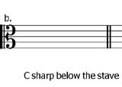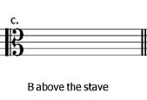
3. Rewrite the following notes at the same pitch but using the alto clef:
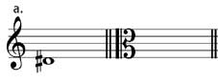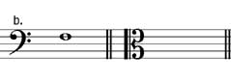
4. Rewrite this melody so that it sounds the same but using the alto clef. Remember to include the clef and key signature.
