SCALES
1. Correct the mistakes in the following scales. There could be one or two mistakes in each scale.
D melodic minor ascending
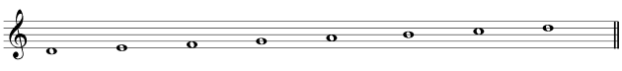
F melodic minor descending
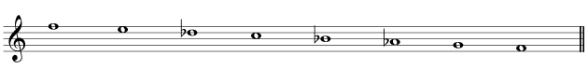
F sharp harmonic minor descending
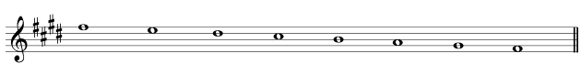
G flat major descending
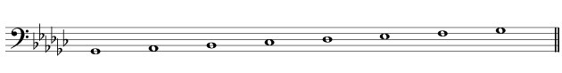
A flat major ascending
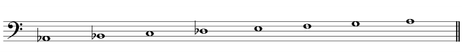

2. Write one ascending octave of the major, minor harmonic and minor melodic scales that have these key signatures, (add any necessary accidentals). Use semibreves and start on the tonic. Name the key of each scale.

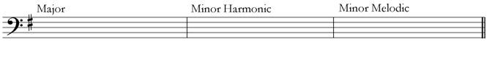

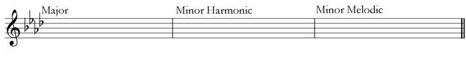

3. Write one octave ascending of each of the following scales. Do not use a key signature but put in all the necessary sharp or flat signs. Use semibreves and begin on the tonic.
D flat major
C melodic minor
E major
E flat major
A melodic minor
4. Write one descending octave of the major, minor harmonic and minor melodic scales that have these key signatures, (add any necessary accidentals). Use semibreves and start on the tonic. Name the key of each scale.
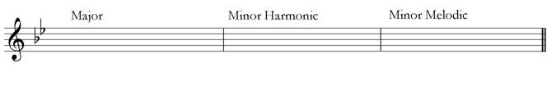
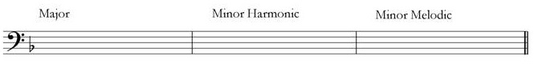
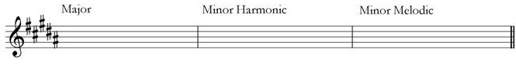

5. Write one octave descending of each of the following scales. Do not use a key signature but put in all the necessary sharp or flat signs. Use semibreves and begin on the tonic.
B flat harmonic minor
D major
C sharp melodic minor

6. Draw a bracket over four successive notes in the right-hand part that form part of a chromatic scale, and over five successive notes in the left hand that form part of a chromatic scale:
