SYMBOLS

Write the name or meaning of each of the following symbols/terms.
1 | (for a string player) |  | 2 | 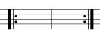
3 | 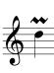 |  | 4
5 |  |  | 6 | t.c.
7 | 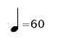 |  | 8
9 |  |  | 10 | 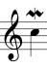
11 | Con sord. |  | 12 | Arco
13 | 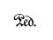 |  | 14
15 |  |  | 16 | FFF
17 | 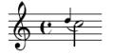 |  | 18
19 |  |  | 20 | 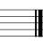
21 | 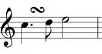 |  | 22 | 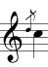
23 | Pizz. |  | 24 | 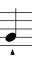
25 |  |  | 26
Draw/write each of the following indications.
1 | Staccato |  | 2 | Breve/double whole rest
3 | Trill |  | 4 | Release the damper pedal
5 | Minim rest (half rest) |  | 6 | Pause/fermata
7 | Demisemiquaver/Thirty-second note |  | 8 | Play until the end
9 | Stop using the mute |  | 10 | Play until the coda sign
11 | Go back to the beginning |  | 12 | Very quiet
13 | Gradually get quieter |  | 14 | One note very loud
15 | Press the right piano pedal |  | 16 | Moderately loud
17 | Go back to the sign |  | 18 | Play with the mute
19 | Staccatissimo |  | 20 | Coda sign
21 | Crotchet/quarter rest |  | 22 | Semibreve rest (whole rest)
23 | Accent |  | 24 | Breve (double whole note)
25 | Double bar (end of section) |  | 26 | Hemidemisemiquaver (sixty-fourth note)

