TRANSPOSING

1. The following melody is written for clarinet in B flat. Transpose it down a major 2nd, as it will sound at concert pitch. Use a key signature and remember to put in all necessary sharp, flat or natural signs.
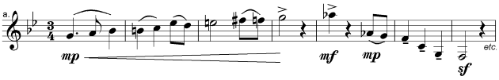
2. The following melody is written for horn in F. Transpose it down a perfect 5th, as it will sound at concert pitch. Use a key signature and remember to put in all necessary sharp, flat or natural signs.
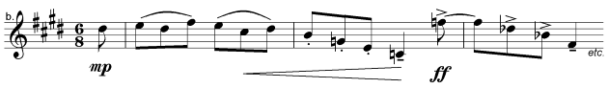
3. These are the actual sounds made by a clarinet in A. Rewrite the passage as it would appear for the player to read, that is, transpose it up a minor 3rd. Do not use a key signature but remember to put in all the necessary sharp, flat or natural signs.
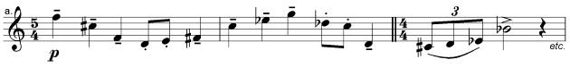

4. These are the actual sounds made by a horn in F. Rewrite the passage as it would appear for the player to read, that is, transpose it up a perfect 5th. Do not use a key signature but remember to put in all the necessary sharp, flat or natural signs.
